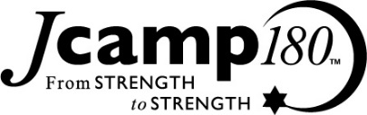

SAMPLE Pledge Reminder

DATE

«LABELNAME»
«opt_line»
«address»
«city», «state» «New_Zip»

Dear «salutation»,

Thank you so much for your generous pledge of support to Camp Ramah in New England’s Capital Campaign. With your participation, our summer home has been markedly enhanced. This summer, we are celebrating the opening of three facilities: the Bet Am Gadol, a state-of-the-art gymnasium, theater and communal space; the K’far Nivonim, a village to house our oldest campers as they attend our leadership program; and the Misrad-Bet Omanut-Nagarut renovations at the entrance to camp that will greatly enhance our arts program and provide much-needed modern administrative facilities. These projects will help ensure Camp Ramah's long-term viability and will enhance our summers for a generation to come.

Below, please find details regarding your pledge.

If you have any questions, please do not hesitate to contact me at 781.702-5290 x225 (or, after June 8, at 413.283.9771) or rhondap@campramahne.org.

Your support is greatly appreciated.

Sincerely yours,

Rhonda Parker
Director of Development and Capital Campaign

Pledge Details (As of DATE):
Fund Name | Pledge Date | Amount Pledged | Current Balance | Due
«gl_code_desc» | «gift_date» | $«total» | $«balance» | $«bill»

