**Sample Donor Database Data Entry Standards – Camp Wonderful**

These standards have been defined to ensure data is entered consistently by all users of the system. For our data to be as useful as possible in our outreach and fundraising efforts, the data must remain as clean and consistent as possible. For example, if some alumni are not flagged as alumni, accurate alumni email/mailing lists cannot be created. If EVERY record does not have the Salutation field filled in completely, personalized emails or mailings cannot be created.

As our processes and requirements evolve over time, these standards may need to be revisited as well. If you have any questions about the standards or have ideas to improve them, contact our database manager or development director.

**General Standards**

* Only one record in the system for each person. Search for a person in the database to be sure they are not already there before entering a new record.
* Every household will have a single record in the database.
* When there are two adults in a household, the person most connected to camp will be designated the primary person on the record (i.e., the alum or the person who reached out to camp initially)
  + The other partner’s information must be entered in the Spouse/Partner fields on the Main tab in the database.
* Children information (if known) is to be entered in the Children fields on the Bio Tab.
  + When children who have their own relationship to camp (alumni, former staff) turn 18, a separate record will be created for them. Use the Link functionality to connect the child to their parents.

**Name Standards**

* The first name field will include the person’s legal name (if known). For example, “James” NOT “Jimmy”
* Nicknames will be used in the **Salutation field** **(1)**. For example, “Jimmy” NOT “James”
  + The Salutation field will be used to personalize letters and emails.
  + For couples, the Salutation field will include both partners’ nicknames (i.e., Marge and Homer) exactly how they would like it written at the top of their communications (“Dear Marge and Homer.”)
* The most formal designation must be entered in the **Publish Name As (2)** field. For example, “Mr. and Ms. Homer J. Simpson.” For a single person, it might read “Mr. Homer Simpson” or “Dr. Marge Simpson.”
  + This allows envelope labels to be printed in bulk with no spreadsheet manipulation.

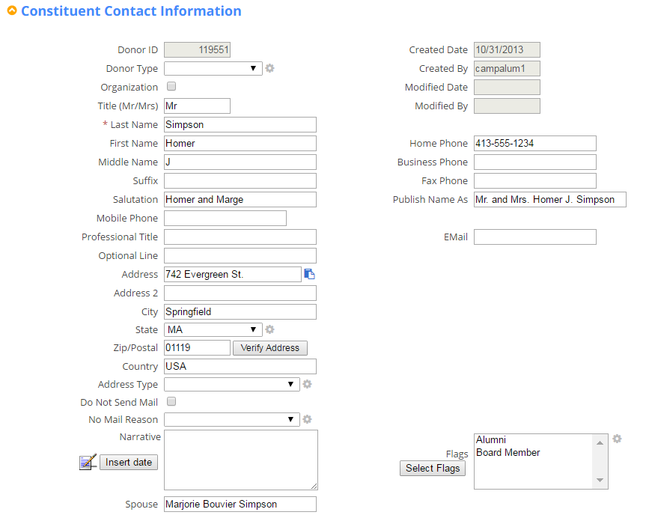

1

2

3

4

5

6

7

**Address Standards**

* Enter standard address abbreviations for all street addresses (in **Address (3)** field). For example, use:
  + “St.” NOT “Street”
  + “Ave.” NOT “Avenue”
  + “Blvd” NOT “Boulevard
  + “Dr.” NOT “Drive”
* For **State (4)**, always use the 2 letter Postal Abbreviation. For example, “NY” NOT “New York.”
* For **Country (5)**, use “USA” for the United States.

**Flags (6)**

Whenever a new constituent is entered, be sure they are flagged with all known designations. These flags are necessary for us to send segmented communications to our constituents. For example:

* If the data is from an Alumni entry form on the website, or from an Alumni reunion, flag them as Alumni.
* If the data is from a list of current parents, flag them as Parent.
* If the constituent is a grandparent of a current or former camper, flag them as Grandparent.
* If you know the couple met at camp and are now married, flag them as Camp Couple.
* If they serve on the Board, flag them as Board Member.
* If they are currently (or formerly) a staff member, flag as Staff.
* Etc.

**Do Not Mail (7)**

* If a constituent requests to be removed from mailing lists, do NOT delete them from the database. Instead, check the “Do Not Mail” checkbox and select “Requested no mail” in the “Do Not Mail Reason” field.
* If a constituent passes away, check the “Do Not Mail” checkbox and select “Deceased” in the “Do Not Mail Reason” field.
  + Note: If the constituent has a partner in the record, simply move the partner information into the main fields, update the “Salutation” and “Envelope Name” fields, and put a note about the deceased in the “Notes” field.

**Other Biographical/Contact Information Standards**

* If a birthdate is known, enter it in the “Birthday” field. This allows us to segment our data by age. Use format MM/DD/YYYY
* Enter Phone numbers in format (###) ###-####

**Gift Entry Data Standards**

When entering a Gift, it is important to enter all data consistently so that we can prepare prompt, accurate thank you notes and analyze our fundraising efforts.

Note that you should check the donor’s record before entering a gift to see if they have an outstanding pledge. If the new gift is actually a payment towards the pledge, be sure to go to the Pledge and click “Apply Payment” to ensure the pledge balance is updated correctly.

* **Reference (1)**: Enter the Check # in the Reference field, where applicable.
* **GL_Code (2) (General Ledger Code)**: Be sure to select the Fund where the money from the gift will be deposited. GL_Codes should match our bookkeeping funds 1:1. If any GL_Codes are missing, let the database manager or development director know ASAP.
* **Campaign (3)**: Select the appropriate campaign for the particular gift. This could be a specific Capital Campaign, the Annual Campaign, a Scholarship Campaign, or other specific fundraising campaign.
* **Solicitation (4)**: Select how the gift was solicited the most likely method the gift was asked for. For example, if a gift comes in the mail with a stub from a mailing, select “Direct Mail.” If the gift came via the basic online giving form, select “Online Giving.” If the gift was solicited in-person, select “In Person.” If the gift was received during camper registration, select “Camper Registration Form.”
* **Split Gifts (5)**: If the gift was a single check or online gift, but requested it be split to multiple Campaigns or Funds, use the Split Gift functionality to track where the contribution should be designated.
* **Soft Credits**: If the gift is actually a shared gift among more than one household in the system, it still can only be entered once in the database – on the record of the person who actually submitted the payment. However, the Soft Credit functionality should be used to ensure the gift is noted on each donor’s record in the system, but the gift is only counted once for giving totals. After entering the gift, use the **Link Gift (6)** option to find the other people in the database to be included in the gift.

1

2

3

4

5

6

