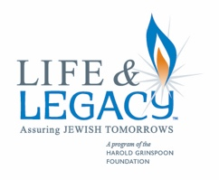
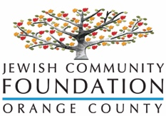
Create a Jewish Legacy
LEGACY GIFT CONFIRMATION

I/We _____________________________, of ______________________, ____________ confirm that I
(Name(s)) (City) (State)

legally provided for my commitment to the Create a Jewish Legacy Program of Orange County, California for the benefit of the following local institutions: (check all that apply)

_____ Beth Jacob Congregation of Irvine _____ Jewish Federation & Family Services OC
_____ Bureau of Jewish Education OC _____ Tarbut V’Torah
_____ Community Scholar Program _____ Temple Bat Yahm
_____ Hebrew Academy _____ Temple Beth El
_____ Heritage Pointe _____ Other __________________________

I have provided for this gift within my estate plan and confirm I have made the appropriate legal arrangements to ensure this will be accomplished on or about the time of my passing (or I have already funded a permanent endowed gift). I have currently provided that my commitment is acknowledged within the following document:

____ Bequest in my will or trust ____ Life Insurance Policy
____ Remainder of IRA and other retirement plan ____ Charitable Remainder Trust
____ Gift of real estate, securities or other property ____ Donor Advised Fund
____ Charitable Gift Annuity ____ Endowment already funded during lifetime

OPTIONAL: Assistance to provide for my legacy commitment (please designate adviser):
My estate planning attorney is: _________________________________ Phone/email: ___________________
My financial planner is: _______________________________________ Phone/email: ___________________

Donor name(s): ___________________________________________________________________________
Address: _________________________________________________________________________________
City/State/Zip: ____________________________________________________________________________
Phone: _________________________________ Email: ___________________________________________

_________________________________________ _________
Signed Date
_________________________________________ _________
Signed Date

Create a Jewish legacy is sponsored and presented by the Jewish Community Foundation of Orange County and is a collaborative effort of the local agencies, synagogues and day schools listed above.

The Jewish Community Foundation’s professional staff is here to assist you in fulfilling your philanthropic goals. Please contact us for more information.

If you have not already submitted confirmation of your legacy gift, PLEASE COMPLETE AND RETURN TO: Jewish Community Foundation Orange County
1 Federation Way, Suite 210
Irvine, California 92603
949.435.3490 www.jcfoc.org info@jcfoc.org

